Name: GRACE BASUBI
Date: 28th, September, 2026
Course: Software Engineering Essentials
Class title: Student

Task 1: Flutter & Dart Environment Setup

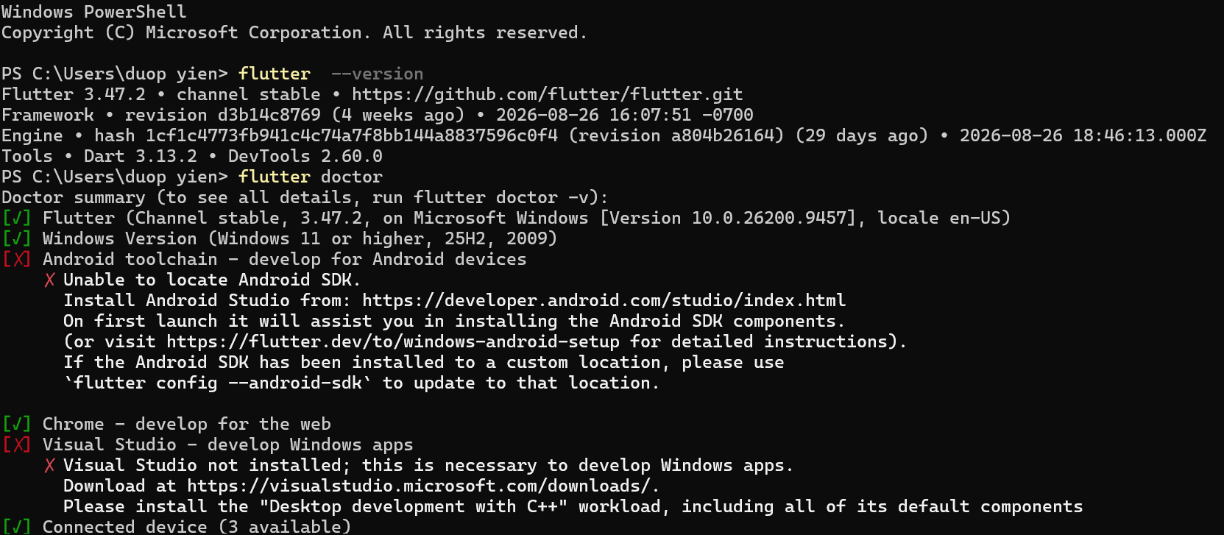

Task 2: MySQL Database Management

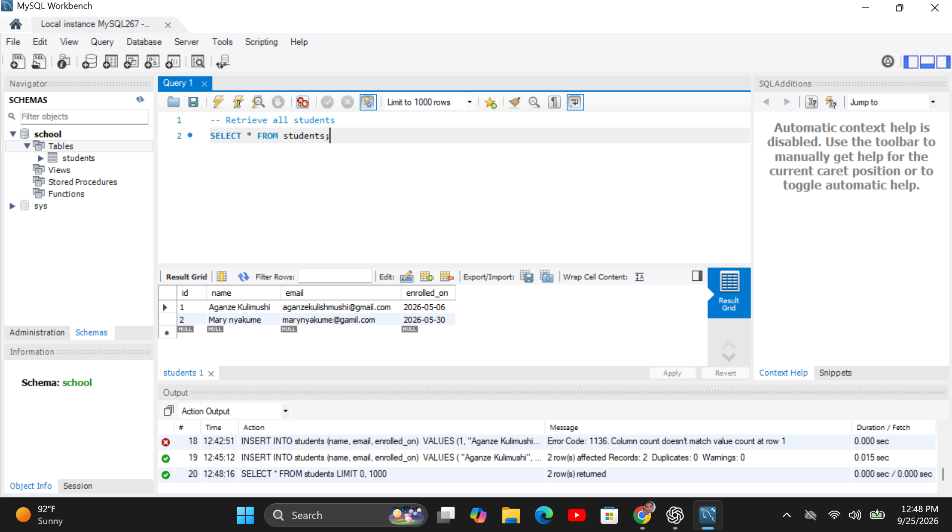

It is not advisable to use the MySQL root account to connect directly to the application backend since it gives too much control over the database server. Furthermore, it violates the principle of least privilege. In case somebody gets access to the root account credentials, they will be able to drop databases, alter data, create new accounts, and perform other operations with the database the application backend since it gives too much control over the database server. Furthermore, it violates the principle of least privilege. In case somebody gets access to the root account credentials, they will be able to drop databases, alter data, create new accounts, and perform other operations with the database.

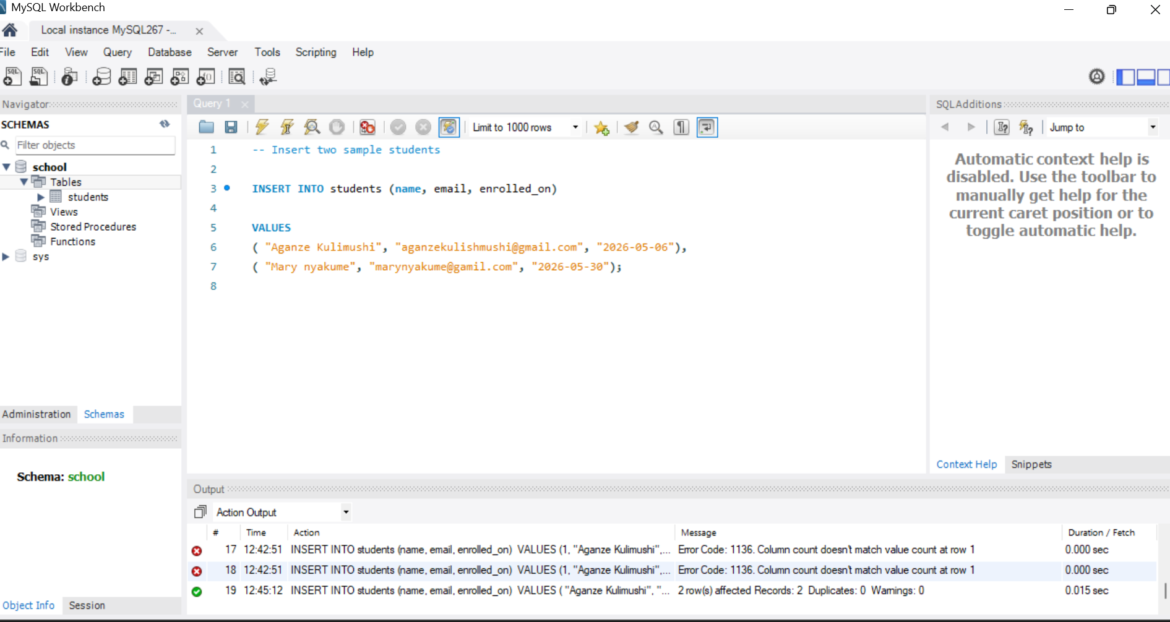

Task 3: Python Environment & Dependency Isolation,

Creation commands; cd Python_Setup_Lab
Activation command; Set-ExecutionPolicy and env\Scripts\activate
package installation; pip install requests

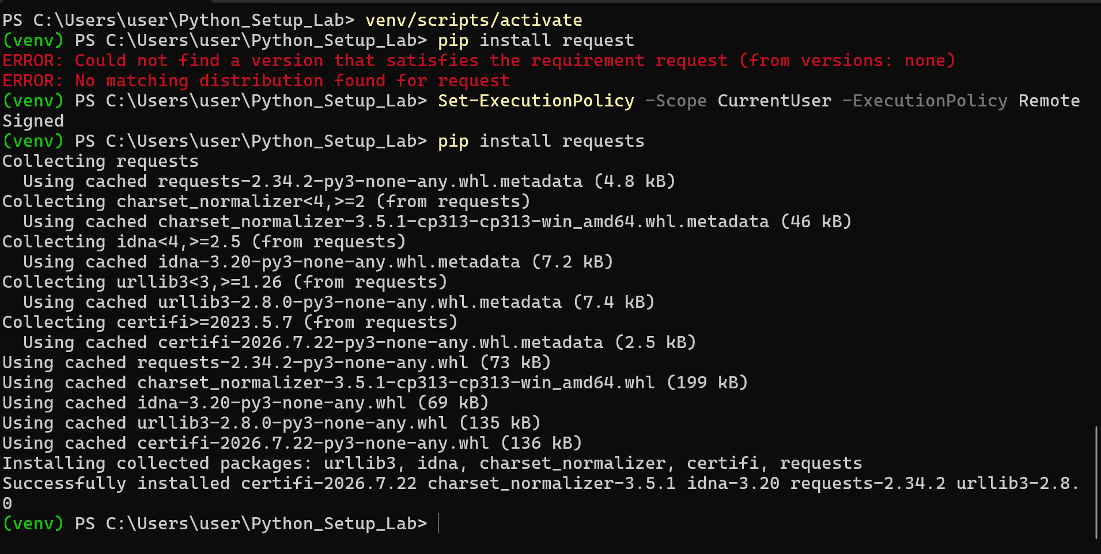

Task 4: VS Code Workspace Configuration

